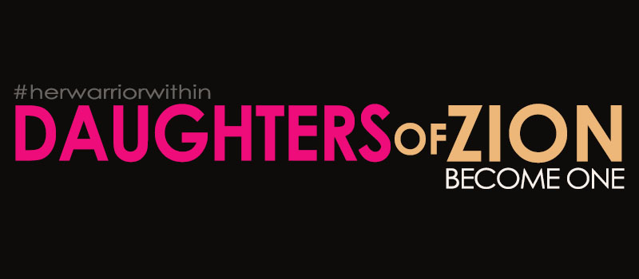
Pay attention! I am speaking to you! Wake up from your place of comfort. Stand up to begin your journey. Sit in your place of destiny. Open your eyes, dig deep inside and stir yourself up! GET EXCITED!
Completely wrap yourself in my presence, completely immerse yourself with my spirit. I AM has secured you, armed you and your praise will go before and behind you.
You are entering into my covenant of peace, of hope, of double restoration. This place has been deliberately prepared; deliberately chosen where in my presence you will be adored.
Be strong, and gird yourself with bravery, with intent, with determination. You are about to bear fruit in peace. You will be adorned as a royal daughter, noticed by the enemy.
For the false, lost enemy that hates you because of your faith, your heart, your purpose will no longer distract you, align with you, terrorize you, blindside you, bring others against you.
Aggressively shake yourself free with determination to destroy, shake off, and overthrow your past, your garbage, your destruction, your shame, your secrets.
ARISE, stand up! You are powerful now that you have committed. Maintain your strength, your posture. Be established and carry out your destiny. You are bound to me now. I will repair, and validate your past. I will prove and fulfill my calling on your life.
I am in covenant with you to settle you, and remain with you as you ascend to your place of honor.
Oh, my adored, be free. Throw off, remove, let loose the chastisement, the cords, the heavy burdens. You have been imprisoned by your own doing. You have been restrained, besieged, and confined in your purpose by your choices. Release and be hostile towards the enclosure of the enemy.
Oh, my child that was led into captivity, and became a prisoner, exiled. Oh, my Daughter, the apple of my eye, my precious creation. I will build a kingdom through you. You will bear fruit.
THUS SAYETH THE LORD
You have given yourself away, merchandised yourself, surrendered yourself into slavery for what? For nothing. Freely you walked away, with no purpose and in vain.
I will redeem you with a vengeance, I will pay with a ransom, because you are mine. I need not buy you for a price, I will redeem you with my grace.
I will bring you home.
I will establish Zion.

